Dhuha Baqarish

PAND

Project 1: Predicting Catalog Demand

## **Step 1: Business and Data Understanding**

### **Key Decisions:**

*Answer these questions*

**1. What decisions needs to be made?**

The decision that needs to be made is to send the catalog to 250 clients or not, based on the profit that will be calculated .

**2. What data is needed to inform those decisions?**

We are given two files of dataset ( customers.xlxs and mailing.xlsx. ), From this two files we need :

Avg_Num_Products_Purchased, Customer Segment, Score_Yes.

In addition to :

- cost of catalogue and that equals($6.50)

- gross_margin (50%) to find the profit.

## **Step 2: Analysis, Modeling, and Validation**

***Important:******Use the p1-customers.xlsx to train your linear model.***

*At the minimum, answer these questions:*

1. **How and why did you select the predictor variables in your model?**

The target variable for the analysis is Avg_Sale_Amount .

And the predictor variables selected for the model are Customer_Segments and Avg_Num_Products_Purchased .

The reason for we selected this two variables as predictor variables is because their p-value less than 0.05 which that mean these two variables are statistically significant.

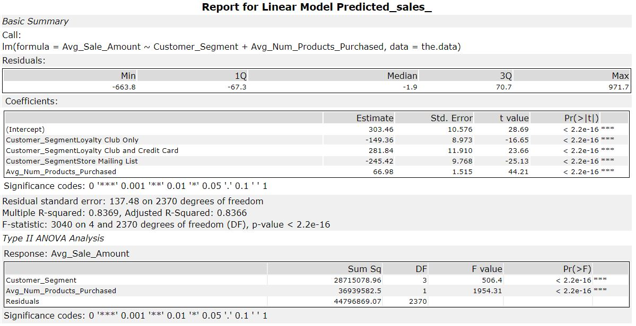

The relationship between Avg_Sale_Amount and Customer_Segments represent by scatterplot :

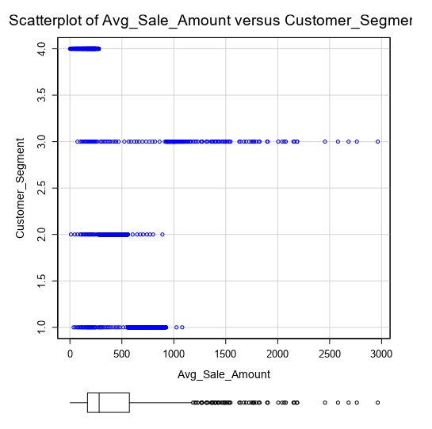

The relationship between Avg_Sale_Amount and Avg_Num_Products_Purchased represent by scatterplot :

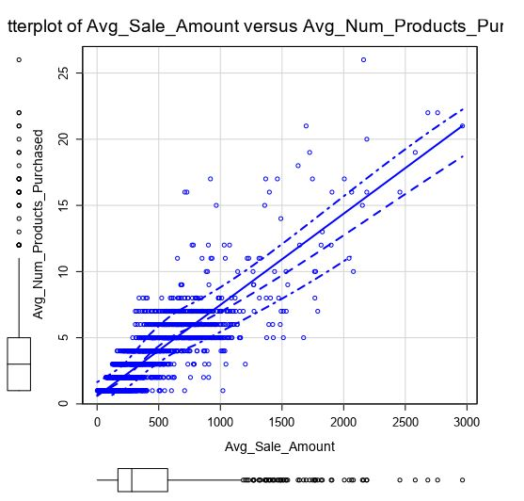

**2. Explain why you believe your linear model is a good model.**

As shown below :

- The Customer_Segment and Avg_Num_Products_Purchased have p-values less than 0.05.

- The Adjusted R Squared value isequal 0.8366 which is quite a large value.

This mean that our model is a good model because p-values and R-Squared value is statistically significan



**3. What is the best linear regression equation based on the available data? Each coefficient should have no more than 2 digits after the decimal (ex: 1.28)**

**The regression equation form:**

*Y = Intercept + b1 * Variable_1 + b2 * Variable_2 + b3 * Variable_3……*

Avg_Sales_Amount = 303.46 + ( -149.36 * Customer_Segment :Loyalty Club Only ) + ( 281.84 * Customer_Segment :Loyalty Club and Credit Card ) + ( -245.42 * Customer_Segment :Store Mailing List ) + ( 66.98 * Avg_Num_Products_Purchased )

## **Step 3: Presentation/Visualization**

*At the minimum, answer these questions:*

**1. What is your recommendation? Should the company send the catalog to these 250 customers?**

Yes, the company should send these catalogues to these 250 customers.

**2. How did you come up with your recommendation?**

I will explain the process in steps ::

1. calculated predicted_sales_amount using the linear regression and score tools (linear regression model) .
2. After that, I created a new column Predicted_Average_Sales = predicted_sales_amount * Score_Yes , by using formula tool .
3. Then the profit is calculated with the given margin to be 50% and cost of each catalogue as $6.50, for all the 250 customers , sush as :

Profit = ([Profit_avg]*0.50)-(250*6.50)

**3. What is the expected profit from the new catalog (assuming the catalog is sent to these 250 customers)?**

Profit = ([Profit_avg]*0.50)-(250*6.50) = 21987.4356865455 $

**Alteryx Workflow :**

